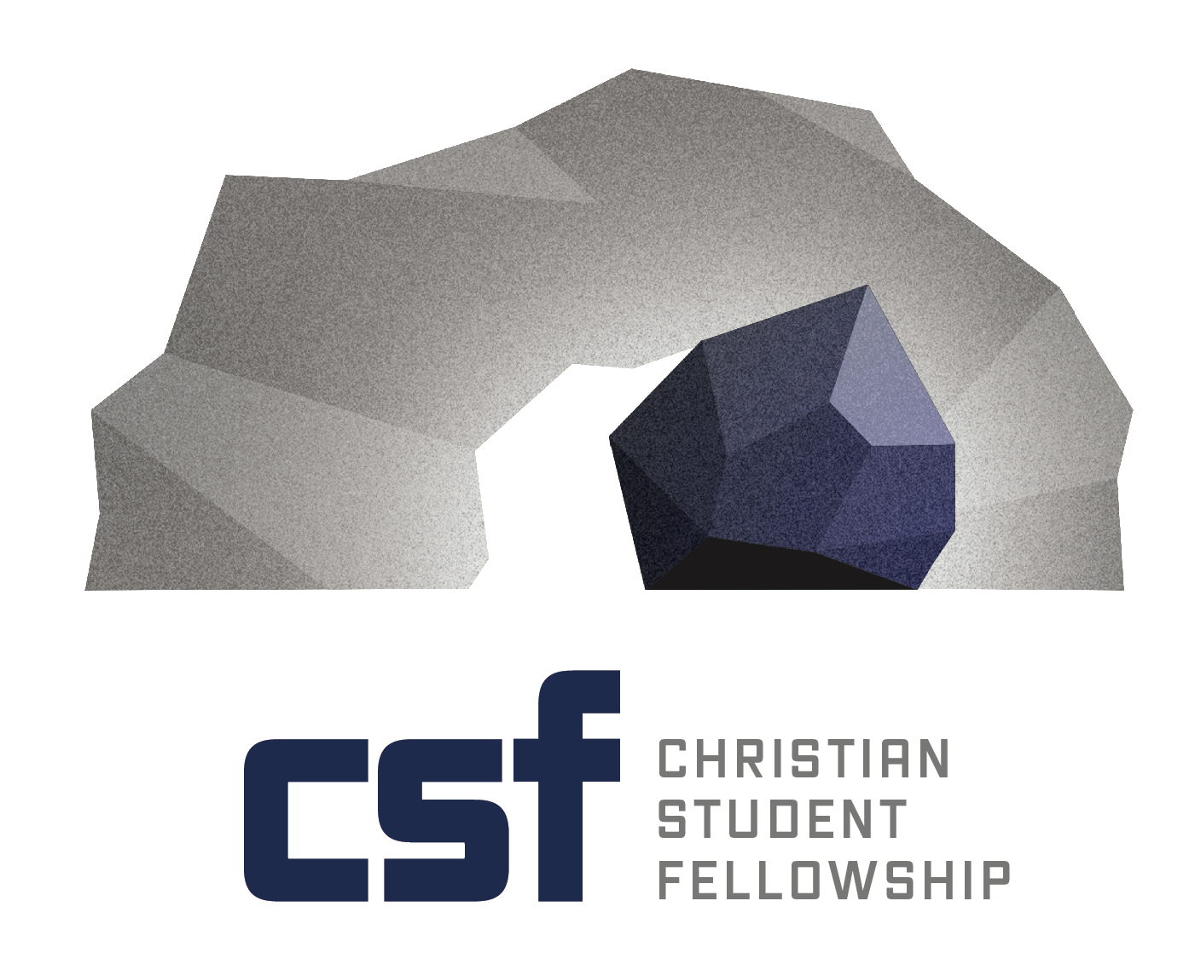
Collegiate Ministry opportunity
Campus Minister
Christian Student Fellowship
Pennsylvania College of Technology

Summary: The Christian Student Foundation of Pennsylvania (CSFPA) a collegiate ministry organization with headquarters in State College, PA is seeking a qualified individual(s) who will partner with CSFPA’s ministry planting team in establishing a Christian Student Fellowship at the Pennsylvania College of Technology located in Williamsport, PA.

Penn College is a national leader in applied technology education with over 100 different majors from nursing to equipment operators to pastry arts. Casually known by the local residents as “Penn Tech”, Penn College is affiliated with the Pennsylvania State University system and offers associate and baccalaureate degrees.

The successful applicants must have a calling and a heart for campus ministry with a strong vision and desire to see the advancement of God’s Kingdom through teaching biblical principles. The successful candidates must demonstrate organizational experiences contributing effectively to ministry excellence. Essential qualities and skills include, but are not limited to, good knowledge of the trades skills, planning, organizational and management skills, excellent public speaking and communication abilities, great energy and creativity, capacity to work with others, ability to resolve problems, and sound judgment.

As is typical in many ministry organizations, CSFPA is a faith-based ministry relying on faithful contributions of individuals and congregations. Therefore, the candidate is expected to be the primary support raiser for this position.

Review of applications and nominations will begin immediately and continue to be accepted until the position is filled. Application materials should include a letter of interest, resume, and the names and contact information of at least three references.

Basic Responsibilities:
- Provide biblical teaching and counseling to students
- Evangelism/Discipleship of students
- Provide/Demonstrate leadership accountability (spiritual and organizational)
- Plan/Organize all semester events along with student leadership
- Create and maintain financial support base with congregations and individuals

Specific Responsibilities:
- Develop leadership resources/training of student leadership
- Work with student leaders to develop outreach to campus
- Establish evangelistic bible studies
- Cultivate relationships with students from which to mentor, counsel, and disciple
- Create missions/service opportunities for students

Brief Description
It is our desire CSF will be an evangelistic/discipleship fellowship based on Jesus’ words in Matthew 28:18-20 with a focused large group fellowship gathering for praise and worship. Social activities will include hayrides, campfires, movies and lots more. Cross-cultural and short term mission projects along with retreats provide will provide opportunity for service and spiritual growth.

The mission of CSF:
Love God… allowing God to change every area of our lives and make us more like Christ.
Love God’s people… encouraging one another in Christ through accountability and activities.
Love God’s world… demonstrating an unconditional love through a message of hope.

The goals of CSF:
Walk… read/study the Bible regularly and spend time talking with God.
Worship… offer oneself to God and meet weekly with other believers.
Message… declare/affirm our hope through Christ.
Ministry… minister to others using spiritual gifts
Share… experience community through small groups
Serve… touch others through time, talents and treasures.

Expectations:
Leadership is a key to an effective ministry. CSFPA is a faith-based ministry relying on faithful contributions of individuals and congregations. Therefore the campus minister is expected to be a primary support raiser for his ministry. CSFPA is looking for someone who can lead others to the Lord, who is experienced in one-on-one discipleship and also can mentor others. As an effective communicator with young adults, the campus minister should consider himself a lifetime student of scripture and the world in which we live. The campus minister must share a conviction that every area of study in academia is a study of God’s creation and human alienation from Him, therefore helping students develop a Christian world and life view is vital to ministry. Finally, one of the essential qualities of a campus minister is a passion for God. The campus minister will have a big impact on young lives and must lead by example. Just as Paul states, “Follow me as I follow Christ”, so the campus minister must be an open book for students to observe and understand.

For additional information or to submit your resume contact David Hershey, Assistant Executive Director of CSFPA, at dave@csfpa.com.

