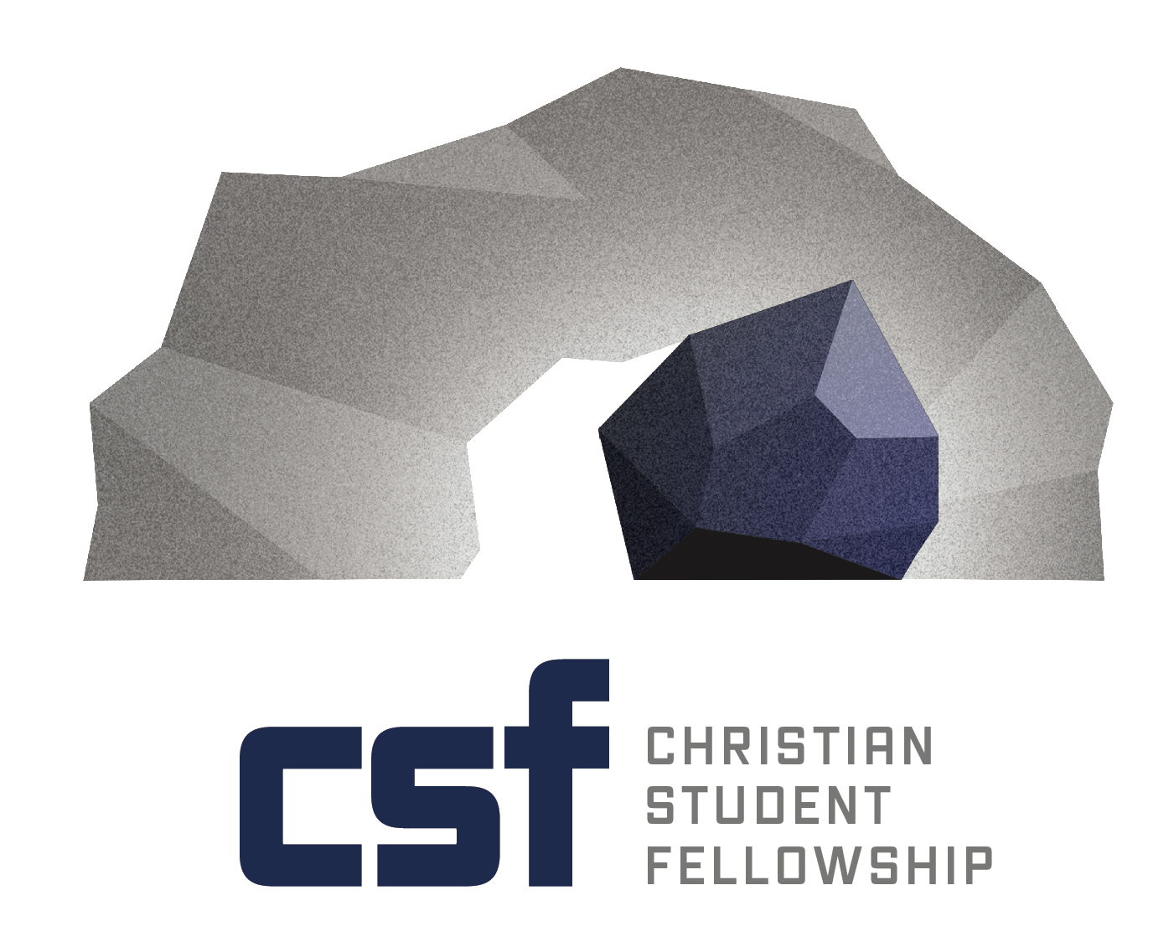
Job Description
Campus Minister
Penn State University
Brandywine campus

Summary:
Penn State Brandywine is part of the Pennsylvania State University system. Located twenty miles from Philadelphia, the Brandywine campus is well-positioned for growing a solid ministry. Many students at Penn State Brandywine commute, however with new dorms opening a couple of years ago, student life is expanding.

Christian Student Fellowship is relatively new on campus. CSF meets regularly for prayer, worship, study, and by seeking ways to be a part of the campus community, desires to work for the good of campus through outreach, evangelism, and acts of love.

Prospective applicants must have a calling and heart for people to grow in their faith in Christ. Additional skills desired include self-motivation, public speaking, and communication, creativity, teamwork, and vision. For further information or questions about the campus ministry, please contact Dave Hershey (Assistant Executive Director of CSFPA) at dave@csfpa.com or phone at 610-763-2445.

Basic Responsibilities:
- Provide Christ-centered discipleship to students that prepare and equip them for lifelong growth in faith and service in the church.
- Cultivate relationships with new students and returning students each year
- Create off-campus mission opportunities for students

- Promote outreach to all students on campus that illustrate the beautiful truths of the Gospel and invites persons to become disciples of Jesus
- Coordinate acts of service and hospitality that demonstrate the love of Christ
- Create spaces where seekers and those interested in the Gospel can investigate Jesus on their own and ask questions in a safe space

- Oversees the student leadership team
- Develop leadership resources and train student leaders
- Assists students In organizing events and activities within the guidelines provided by the University

- Build relationships with churches and individuals that will benefit the ministry.
- Create and maintain financial support base with congregations and individuals
- Creatively find ways to invite churches and individuals to be involved in the ministry

Expectations:
- Leadership – Provide leadership to the students.
- Teacher – Teach, disciple, and share the Gospel.
- Learner – Possess a desire to study scripture, learn new things and be teachable
- Holistic – Share the conviction that every area of study in academia is a study of God’s creation and helps students develop a Christian worldview that integrates their faith with their vocation
- Example – Set a Christlike model for the students to emulate.
- Flexible – Campus is constantly changing and requires adaptability and flexibility.
- Wisdom –Know how to set appropriate expectations for students, knowing when to challenge and convict them and when to give them space to make mistakes.
- Passionate – CSFPA relies on the faithful contributions of individuals and congregations. Therefore a campus minister must be passionate about the ministry, pursuing partners who will donate and fund the work.

Fundraising - campus ministry is funded through financial partnerships. Therefore, the candidate will begin actively fundraising immediately (with coaching from CSFPA staff) and will not begin work on campus until at least 75% of the financial goal is raised.

