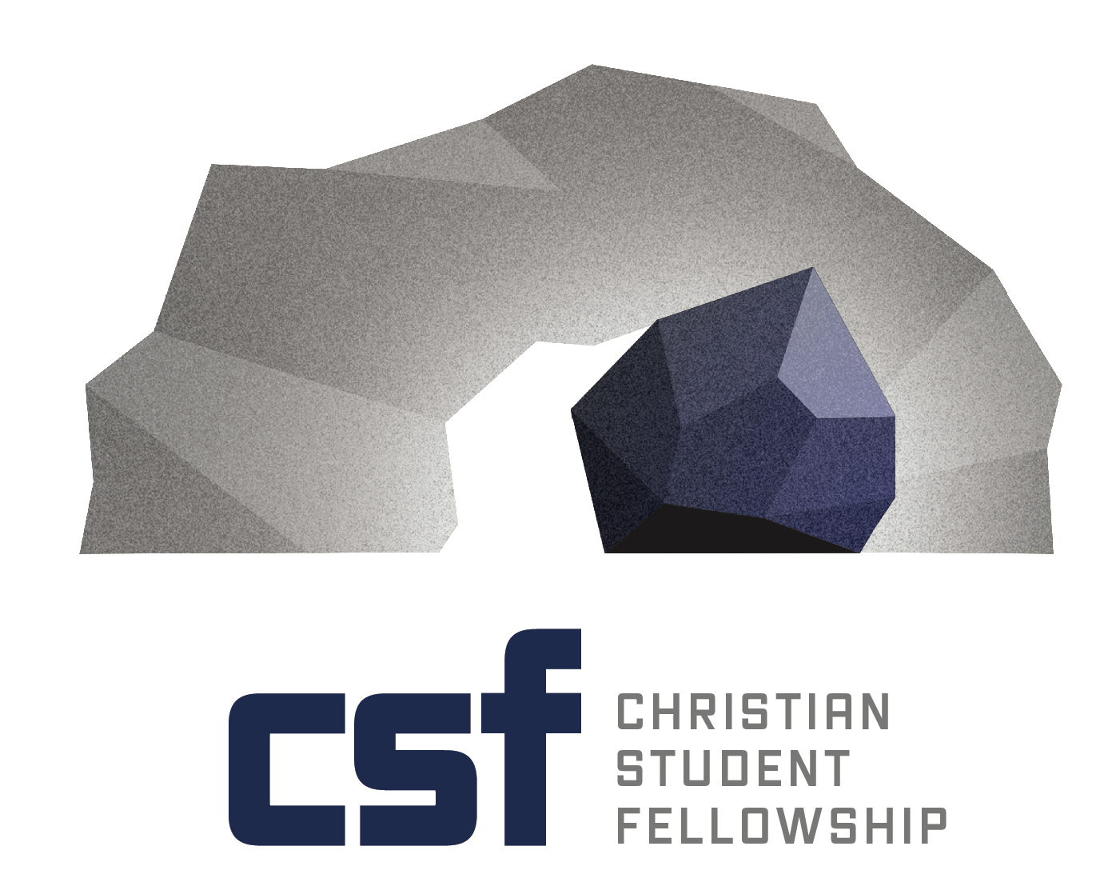
Collegiate Ministry
Apprenticeship Description

Purpose:
To provide direction and training experience for campus ministry through the development of a philosophy of ministry, skills for ministry, and personal ministry resources.

Design:
To develop effective ministry to collegians through evangelism and discipleship.

Ministry Focus:
- Work with current staff in ministry enhancing the overall goals of CSFPA in reaching the University with the gospel
- Assist with administrative duties
- Aid in overseeing general fellowship ministries and activities

General Responsibilities:
- Counsel
- Creative ministry outreach
- Communications
- One on One Discipleship (mentoring)/Relationship building
- Develop leadership support teams (prayer/accountability)
- Oversee achievements of small groups

Ministry Concentration Areas:
Athletics Greek Life Internationals
Administration Worship Ministry Women’s Ministry
Men’s Ministry Small Groups

Length of Apprenticeship
One Year

Interested? Contact us...
Christian Student Foundation Phone: 610-763-2445
PO Box 221 Email: dave@csfpa.com
State College, PA 16804

Guidelines and Responsibilities

for Apprentices

Purpose:

- To provide a positive training experience for campus ministry through the development of a philosophy of ministry, skill for ministry, and personal ministry resources.

- To advance a campus fellowship by involving the apprentice in supervised pastoral, evangelistic and discipleship work.

Focus:

The Apprentice will be involved in a variety of activities within the campus fellowship but will focus on two specific areas. The first will be that of evangelism/discipleship and the second will be determined by his/her strengths and gifts.

General Responsibilities:

1. Travel
As an apprentice with CSFPA you will be required to travel throughout the year with your campus ministry representing the fellowship and overall ministry of CSFPA. Public relations with congregations and individuals is extremely important in building a financial base. The number of times on the road will depend on the campus minister supervising your internship.

2. Fundraising
Each apprentice is responsible for raising his/her support for ministry. Depending upon which campus you decide to minister on, there may be certain stipends that will help in your overall efforts. Fund raising will involve: (1) letter writing followed by a phone call to the prospective donor (2) visiting supporting or non-supporting congregations and (3) anything else the CSFPA board may determine to be effective in establishing your financial base. Any income raised through your efforts will be applied to your “account”. You may have to secure a part-time job due to the lack of sufficient income. This will be with the approval of the supervising campus minister and the CSFPA board of directors.

3. Finances
Living expenses - Depending on which campus you serve, certain living expenses are covered. An example would be housing provided, but you must cover utilities.

Professional expenses - The apprentice does have an allotment for business expenses. It is important that you keep receipts of all transactions for housing and ministry expenses. You must also send a copy of ministry expenses and copies of your receipts with your monthly reports to CSFPA office (IRS regulations). There will be no city, state, or federal taxes withheld from your twice-a-month paycheck, therefore you will be responsible to set aside a portion of your income to cover those taxes. You will need to use a schedule SE as part of your federal tax return.

Projection of expenses worksheet – The apprentice will be required to fill out a financial expense worksheet to determine projected cost of living expenses. These expenses will include housing, business and personal expenses. The supervising campus minister will work closely with the apprentice to determine those projected expenses.

Special Note concerning finances – CSFPA board of directors has determined the salary of the apprentice is dependent upon personal fund-raising efforts.

4. CSFPA Meetings
You will be required to attend the CSFPA Board of Directors meetings. These meetings are opportunities to meet other campus ministers and apprentices. Other reasons would be to see how the board functions and raise issues and concerns for apprentices and general fellowship.

5. Ministry Reports
Each month you will be required to submit a ministry report of the activities of your efforts in furthering the Kingdom of God. These reports should detail progress of your ministry goals, miles traveled, churches visited, decisions for Christ, events within the fellowship, and any other facts you deem important to report on.

6. CSF Fellowship Responsibilities
Responsibilities within the Christian Student Fellowship will depend upon the needs as assessed by the campus minister and staff.

